|  |
| --- |
| KARNATAK LAW SOCIETY’S  GOGTE INSTITUTE OF TECHNOLOGY  UDYAMBAG, BELAGAVI-590008  (An Autonomous Institution under Visvesvaraya Technological University, Belagavi)  (APPROVED BY AICTE, NEW DELHI)    Department of Electronics and Communication Engineering        Course Project Report on  **Gender Recognition Using MATLAB**    Submitted in partial fulfillment of the requirement for the award of the degree of Bachelor of Engineering in  DSP and Architecture    Submitted by  Hrushikesh Kitwadkar  Abhay Kagwad  Aditya Kulkarni  Kaustubh Halyal  Guide  Prof. Vidyarani Katigar    2019 – 2020 |

DECLARATION BY THE STUDENT

We Hrushikesh Kitwadkar, Abhay Kagwad, Aditya Kulkarni, Kaustubh Halyal hereby declare that the course project report entitled Gender Recognition using MATLAB submitted by us to KLS Gogte Institute of Technology, Belagavi, in partial fulfillment of the Degree of Bachelor of Engineering in Electronics and Communication Engineering is a record of the project carried out in DSP and Architecture. This report is for the academic purpose.

We further declare that the course project report has not been submitted and will not be submitted, either in part or full, to any other institution and University for the award of any diploma or degree.

Name of the students: Abhay Kagwad(2GI17EC002)

Aditya Kulkarni (2GI17EC007)

Hrushikesh Kitwadkar(2GI17EC039)

Kaustubh Halyal(2GI17EC043)

Signature :

Place: K L S GOGTE INSTITUTE OF TECHNOLOGY, BELAGAVI

Date:

**ABSTRACT:**

This analysis basically predict the gender of the speaker by analyzing different parameters of the voice sample. It includes simple short-time auto-correlation values of male and female voice samples. All this work is implemented through MATLAB programming. A database can be created easily by collecting voice samples of different people, both male and female.

**INTRODUCTION:**

Speech constitutes one of the most popular and significant means for humans to communicate, express their emotions and intentions to each other. Speech is produced by humans using a natural biological mechanism in which lungs discharge the air and convert it to speech passing through the vocal cords and organs including the tongue, teeth, lips etc. In general, a speech and voice recognition system can be used for gender identification. A natural voice recognition system is the human ear. The human ear has an excellent mechanism which can efficiently distinguish the gender by voice and speech based on attributes like frequency and loudness.

**PROBLEM STATEMENT:**

To create a gender identification system that can be used to identify the gender of the speaker using MATLAB.

**METHODOLOGY:**

In this project we initially recognize the input speech which is the process of converting spoken input to text. It is also known as speech-to-text and Voice recognition. Technically gender recognition is the process of converting an acoustic signal, captured by a microphone. Compare it with a pitch rate(65 to 260Hz for male and 100 to 525Hz for female) and identify which is male and female.

The principle used here is Auto-correlation, also known as serial correlation, it is the correlation of a signal with a delayed copy of itself as a function of delay. It is often used in signal processing for analyzing functions or series of values, such as time domain signals.

**ALGORITHM:**

1)START.

2)Read an audio file from any database or record your own voice using microphone.

3)Find its frequency.

4)Find its maximum speech at 50Hz or any other frequency.

5)Perform autocorrelation of audio signal.

6)If Fx is above a specific threshold then the voice is of male, otherwise it is of a female.

7)Plot Graph.

8)STOP.

**CODE:**

%--------Gender Recognition----------%

fs=8000; % Sampling rate

nbits=16;

nChannels=1;

duration=3; % Recording duration

arObj=audiorecorder(fs, nbits, nChannels);

fprintf("Press any key to start %g seconds of recording", duration); pause

fprintf("Recording");

recordblocking(arObj, duration);

fprintf("Finished recording.\n");

fprintf("Press any key to play the recording"); pause;

fprintf("\n");

play(arObj);

fprintf("Plotting the waveform\n");

y=getaudiodata(arObj); % Get audio sample data

plot(y); % Plot the waveform

ms2 = fs/500;

ms20 = fs/50;

r = xcorr(y, ms20, "coeff");

d = (-ms20:ms20)/fs;

plot(d, r);

title("Autocorrelation");

xlabel("Delay (s)");

ylabel("Correlation coeff");

r = r(ms20 + 1 : 2*ms20+1);

[rmax, tx] = max(r(ms2:ms20));

Fx = fs/(ms2+tx-1);

%recognizing voice

Fth= 160; %% threshold frequency is 160 Hz, you can change this frequency too

if Fx> Fth

disp("It is a female voice!")

else

disp("It is a male voice!")

end

**OUTPUT / RESULTS:**

Male Voice:

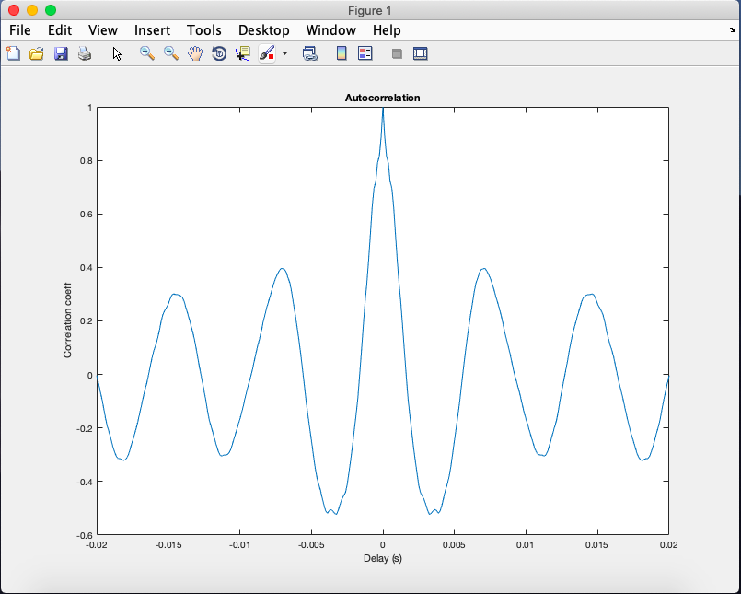

Female Voice:

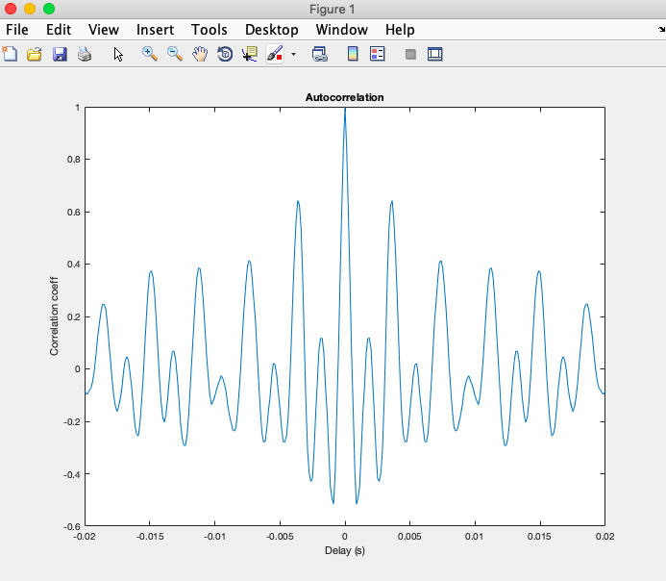

**APPLICATIONS:**

Gender/Voicerecognition has various applications:

1)Human to machine interaction.

2)Sorting of telephone calls by gender categorization.

3)Investigating criminal voice in crime scenarios.

**CONCLUSION:**

This project was about creating a gender identification system using speech. It showed all the necessary technical background and the steps required to make such a system like the digital form of speech, speech enhancement methods, classification method, and relevant features. The performance was evaluated on different tests using different number of parameters. This gave almost 80% accuracy on a large number of speakers.